New Patient Intake Form

Patient Name: Date:
DOB: Age: Male Female
Height: Weight:
Address: City: State: Zip:
Phone: Email:
Marital Status: Minor Single Married
Referred by:
Emergency Contact: Emergency Contact #:
Occupation: Employer:
Primary Care Physician: Phone:
Please mark where your pain is:
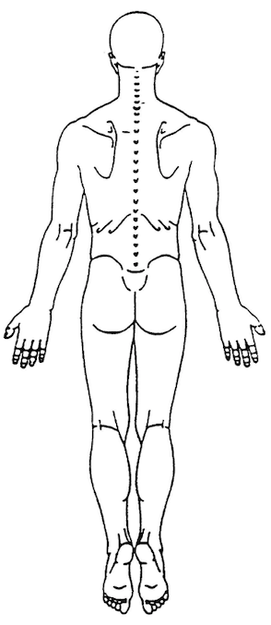
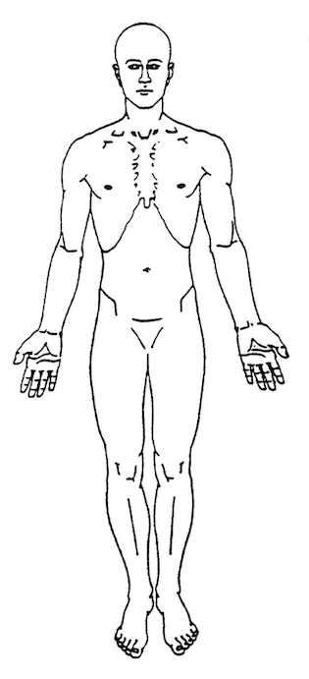
Reason for visit:
Mechanism of injury:
When did injury occur:
Is your injury getting worse? Yes No
Have you had this injury before? Yes No
Have you been treated by a medical physician for this condition previously? Yes No
If so, whom?
Have you been treated by a chiropractor before? Yes No
If so, whom?

Additional information:

Health History (please select all that apply):

- Abdominal pain
- AIDS/HIV
- Allergies
- Anemia
- Anorexia
- Arthritis
- Asthma
- Bulimia
- Cancer
- Chicken Pox
- Constipation
- Diabetes
- Diverticulitis
- Dizziness
- Eczema
- Fainting
- Gastrointestinal disorders
- Gonorrhea
- Gout
- Headaches
- Heart disease
- Hepatitis
- Herpes
- Hypertension
- Kidney disease
- Liver disease
- Lung disease
- Multiple Sclerosis
- Numbness
- Osteoporosis
- Parkinson’s disease
- Polio
- Prostate disease
- Scoliosis
- Stroke

Other:

Social History:
Do you smoke cigars / cigarettes? Yes No If so, how many per day/week:
How many alcoholic beverages do you consume per week?
How many days per week do you exercise? 1-2 3-4 5-6 7
Are you pregnant? Yes No

Medications / Vitamins (please provide dosage/times per day if possible):
Past Surgical / Hospitalization History:

Review of Systems (please select all that apply):
Cardiovascular: chest pain palpitations hypertension heart murmur
Respiratory: asthma shortness of breath cough coughing up blood
Musculoskeletal: cramps muscle pain joint pain bruising/swelling
Neurological: numbness/tingling dizziness headaches unsteadiness
EENT: double vision difficulty hearing sinus infections difficulty swallowing
Dermatological: eczema rash hair loss itching changes in nails
GI: nausea vomiting abdominal pain constipation heartburn ulcers
GU: incontinence blood in urine stones
General: unintentional weight loss weight gain night sweats fatigue
Psychiatric: anxiety depression previous abuse PTSD
Immunological: HIV/AIDS
Other:

Patient Signature: Date:

INFORMED CONSENT DOCUMENT

PATIENT NAME:
To the Patient: Please read this entire document prior to signing it. It is important that you understand the information contained in this document. Please ask questions before you sign if there is anything that is unclear.

The nature of the chiropractic adjustment:
The primary treatment used by a Doctor of Chiropractic is spinal manipulative therapy. The doctor will use that procedure to treat you. The doctor may use his hands or a mechanical instrument upon your body in such a way as to move your joints. That may cause an audible “pop” or “click,” much as you have experienced when you “crack” your knuckles. You may feel a sense of movement.

Analysis / Examination / Treatment:
As a part of the analysis, examination, and treatment, you are consenting to the following procedures (please initial by each of the following that you are consenting to):
Spinal manipulative therapy, palpation, vital signs
Range of motion testing, orthopedic testing, basic neurological testing
Muscle strength testing, postural analysis testing, corrective movement testing
Mechanical massage, cupping, trigger point therapy

The risk inherent in a chiropractic adjustment:
As with any healthcare procedure, there are certain complications which may arise during chiropractic manipulation and therapy. These complications include but are not limited to: fractures, disc injuries, dislocations, muscle strain, cervical myelopathy, costovertebral strains and separations, and burns. Some types of manipulation of the neck have been associated with injuries to the arteries in the neck leading to or contributing to serious complications including stroke. Some patients will feel some stiffness and soreness following the first few days of treatment. The Doctor will make every reasonable effort during the examination to screen for contraindications to care; however, if you have a condition that would otherwise not come to the Doctor’s attention it is your responsibility to inform the Doctor.

The probability of those risks occurring:
Fractures are rare occurrences and generally result from some underlying weakness of the bone which we check for during the taking of your history and during examination and can be evaluated through X-ray. Stroke and /or arterial dissection caused by chiropractic manipulation of the neck has been the subject of ongoing medical research and debate. The most current research on the topic is inconclusive as to a specific incident of this complication occurring. If there is a causal relationship at all it is extremely rare and remote. Unfortunately, there is no recognized screening procedure to identify patients with neck pain who are at risk of arterial stroke.

The availability and nature of other treatment options:
Other treatment options for your condition may include:
- Self-administered, over-the-counter analgesics and rest
- Medical care and prescription drugs such as anti-inflammatory, muscle relaxants and painkillers.
- Hospitalization or surgery
If you choose to use one of the above noted “other treatment” options, you should be aware that there are risks and benefits of such options and you may wish to discuss these with your primary medical physician.

The risks and dangers attendant to remaining untreated:
Remaining untreated may allow the formation of adhesions and reduce mobility which may set up a pain reaction further reducing mobility. Over time this process may complicate treatment making it more difficult and less effective the longer it is postponed.

Financial Policies:
Payments to Premier Sports Chiropractic and Recovery LLC are expected at the time of service. We accept Cash, Check, Debit and Credit. Our office requires a 24-hour cancelation notice by the patient. Any patient who does not show up for their scheduled appointment is considered a “no show” and will be charged the FULL price of that visit during their next appointment. All services provided are explained in detail with prices on the business website.

Insurance:
Premier Sports Chiropractic and Recovery LLC is not in network with insurance companies and patients are required to pay for services in the form of payments described above. We choose not to be in network with insurance companies for the reason that we do not want your treatment to be indicative of what your insurance company deems as medically necessary. We can however provide you the forms to bill your insurance company so that you may receive reimbursement from them directly.

CONSENT TO TREATMENT (IF MINOR):
I hereby request and authorize Dr. Vincent Youngross, D.C. to perform diagnostic tests and render chiropractic adjustments and other treatment to my minor son/daughter: . This authorization also extends to all other doctors and office staff members and is intended to include radiographic examination at the doctor’s discretion. As of this date, I have the legal right to select and authorize health care services for the minor child named above. (If applicable) Under the terms and conditions of my divorce, separation or other legal authorization, the consent of a spouse/former spouse or other parent is not required. If my authority to so select and authorize this care should be revoked or modified in any way, I will immediately notify this office.

DO NOT SIGN UNTIL YOU HAVE READ AND UNDERSTAND THE INFORMATION ABOVE.

I have read and/or have had read to me the above explanation of the chiropractic adjustment and related treatment. I have discussed this document with Dr. Vincent Youngross, D.C. and have had my questions answered to my satisfaction. By signing below, I state that I have weighed the risks involved in undergoing treatment and have decided that it is in my best interest to undergo the treatment recommended. Having been informed of the risks, I hereby give my consent to treatment.

Date Date

Patient’s Name Doctor’s Name

Signature Signature

Signature of Parent or Guardian (if a minor)

